Harmony OS on Raspberry Pie installation 2 (Board level)

1. Work with Raspberry Pie

1.1. Change menuconfigand Kconfig
Like all conversational Linux, kernel compiling configuration is through menuconfig or Kconfig tools，then produced following files .config(kernel\liteos_a.config), if config is succeed. Then run compiling.

1.1.1. board level
Enter to /kernel/liteos_a/ to run following command
make menuconfig
it prompts following output, when finish, a file \kernel\liteos_a\Kconfig is created.
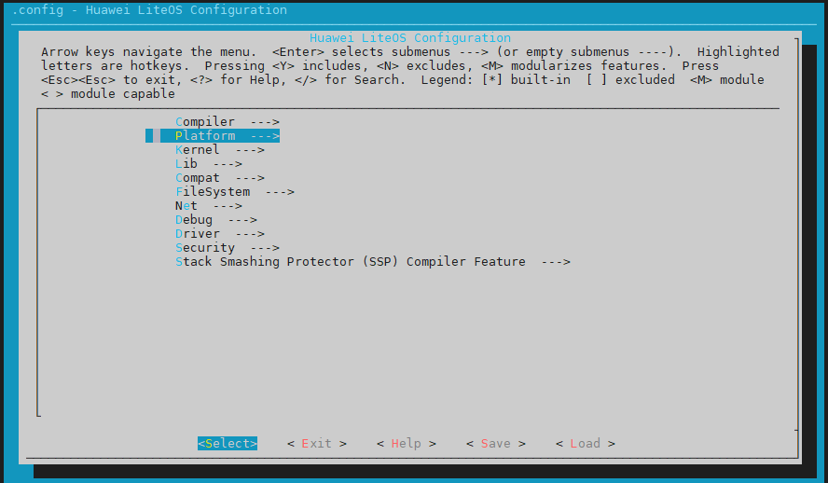
Kconfig contains：
source "../../kernel/liteos_a/platform/Kconfig" # new file Kconfig
source "../../kernel/liteos_a/arch/Kconfig"
...

1.1.2. Modify kernel\liteos_a\platform\Kconfig
Open "../../kernel/liteos_a/platform/Kconfig"，add Raspberry pie related settings
config PLATFORM, add following：
default "Raspberry_Pi_2" if PLATFORM_RASPBERRYPI2
choice ：
config PLATFORM_RASPBERRYPI2
bool "Raspberry_Pi_2"
select ARCH_CORTEX_A7
save the file and rerun make menuconfi, platform will show one more choice
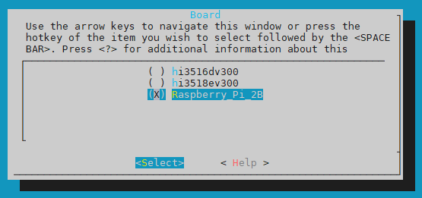

1.1.3. Modify kernel\liteos_a\Kconfig
Related compiling info around line 45-49
config COMPILER_HIMIX_32
bool "arm-linux-ohoseabi"
depends on PLATFORM_HI3518EV300 || PLATFORM_HI3516DV300 || PLATFORM_RASPBERRYPI2
​
config COMPILER_CLANG_LLVM
bool "clang-llvm"
depends on PLATFORM_HI3518EV300 || PLATFORM_HI3516DV300 || PLATFORM_RASPBERRYPI2
After added above two sections, Compiler will show in the choice as follows：
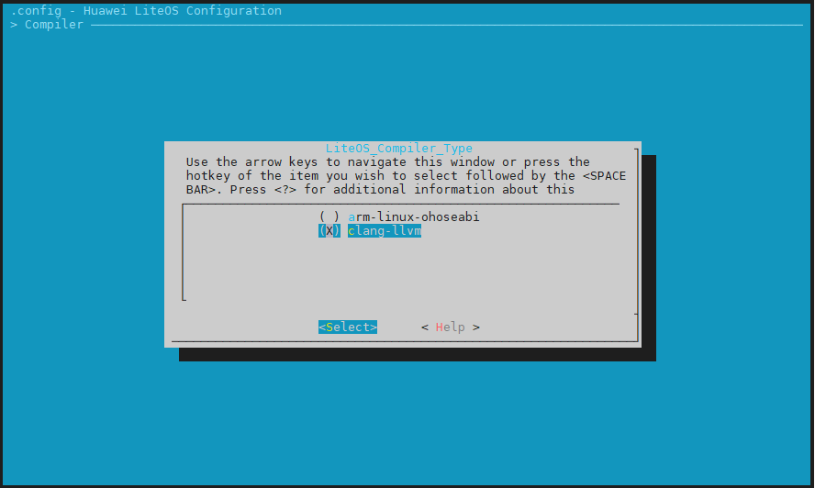
Select the compiler and save it，if check the file \kernel\liteos_a.config，it will have following section added
# Platform
#
LOSCFG_PLATFORM="Raspberry_Pi_2"
# LOSCFG_PLATFORM_HI3516DV300 is not set
# LOSCFG_PLATFORM_HI3518EV300 is not set
LOSCFG_PLATFORM_RASPBERRYPI2=y

1.2. Modify makeand Makefile
Makefile platform/Makefile platform/bsp.mk

1.2.1. Modify kernel\liteos_a\Makefile
File system root is around line 62
ifeq ($(LOSCFG_PLATFORM_RASPBERRYPI2), y)
FSTYPE = jffs2
ROOTFS_SIZE = 0xA00000
endif
In make lib file add board folder，it is around line 10, 7 In source directory add /vendor/ as shown as follows
##### make lib #####
$(__LIBS): $(OUT) $(CXX_INCLUDE)
​
ifeq ($(LOSCFG_PLATFORM_RASPBERRYPI2),y)
BOARD_INCLUDE_DIR := $(LITEOSTOPDIR)/../../vendor/broadcom/BCM2836/board
else
BOARD_INCLUDE_DIR := $(LITEOSTOPDIR)/../../vendor/hisi/hi35xx/$(LITEOS_PLATFORM)/config/board
endif
​
$(OUT): $(LITEOS_MENUCONFIG_H)
$(HIDE)mkdir -p $(OUT)/lib
$(HIDE)$(CC) -I$(LITEOS_PLATFORM_BASE)/include -I$(BOARD_INCLUDE_DIR) \
-E $(LITEOS_PLATFORM_BASE)/board.ld.S \
-o $(LITEOS_PLATFORM_BASE)/board.ld -P

1.2.2. Add board folder
Create an new directory: vendor，creates a broadcom directory under vendor
board structure format：
Cortex/ARCH/manufacturer/IC_No/Hardware/Board_version
Cortex-A7/Armv7-A/broadcom/BCM2836/Raspberry_Pi/..

vendor\broadcom\BCM2836\board\include\asm\platform.h

1.2.3. Modify vendor\broadcom\BCM2836\BCM2836.mk

Base address
BCM2836_BASE_DIR := $(LITEOSTOPDIR)/../../vendor/broadcom/BCM2836

1.2.4、kernel\liteos_a\platform\Makefile
Add makefile，line 43
$(LOSCFG_PLATFORM_RASPBERRYPI2) \
ifeq ($(findstring y, $(LOSCFG_PLATFORM_HI3518EV300)$(LOSCFG_PLATFORM_HI3516DV300)$(LOSCFG_PLATFORM_RASPBERRYPI2)), y)
1.2.5. kernel\liteos_a\platform\bsp.mk

Setup interrupt、timer、serial port、USB， line 58
########################## LOSCFG_PLATFORM_RASPBERRYPI2 Options##############################
else ifeq ($(LOSCFG_PLATFORM_RASPBERRYPI2), y)
HWI_TYPE := arm/interrupt/gic
TIMER_TYPE := arm/timer/arm_generic
HRTIMER_TYPE := BCM2836/hrtimer
#UART_TYPE := amba_pl011
Header file, line 90
ifeq ($(findstring y, $(LOSCFG_PLATFORM_HI3518EV300)$(LOSCFG_PLATFORM_HI3516DV300)), y)
PLATFORM_INCLUDE += -I $(LITEOSTOPDIR)/../../vendor/hisi/hi35xx/$(LITEOS_PLATFORM)/config/board/include/hisoc
else ifeq ($(LOSCFG_PLATFORM_RASPBERRYPI2),y)
PLATFORM_INCLUDE += -I $(LITEOSTOPDIR)/../../vendor/broadcom/BCM2836/board/include
endif

1.2.6. drivers\hdf\lite\hdf_lite.mk
Setup HDF top level directory，line 39
include $(LITEOSTOPDIR)/../../vendor/huawei/hdf/hdf_vendor.mk
Replaced by：
ifeq ($(findstring y, $(LOSCFG_PLATFORM_HI3518EV300)$(LOSCFG_PLATFORM_HI3516DV300)), y)
include $(LITEOSTOPDIR)/../../vendor/huawei/hdf/hdf_vendor.mk
endif
​
ifeq ($(LOSCFG_PLATFORM_RASPBERRYPI2), y)
include $(LITEOSTOPDIR)/../../vendor/broadcom/hdf/hdf_vendor.mk
endif

1.2.7. vendor\huawei\hdf\hdf_vendor.mk（TODO)
Board HDF file path，line 18
else ifeq ($(LOSCFG_PLATFORM_RASPBERRYPI2), y)
LIB_SUBDIRS += $(LITEOS_SOURCE_ROOT)/vendor/broadcom/BCM2836/config
VENDOR_HDF_DRIVERS_PLATFORM_ROOT := $(LITEOSTOPDIR)/../../vendor/broadcom/BCM2836/platform # this directory added later

1.3. Compiling
Adjust kernel\liteos_a\tools\build\mk\los_config.mk to make compiling, HIDE has no value，run make,
HIDE := #delete @ to show the output of “make”
1.3.1. modify following 4 files
kernel/liteos_a/shell/full/src/base/show.c
kernel/liteos_a/shell/full/src/base/shcmd.c
kernel/liteos_a/shell/full/src/base/shmsg.c
kernel/liteos_a/shell/full/src/cmds/dmesg.c
#elif defined LOSCFG_PLATFORM_RASPBERRYPI2
#include "uart.h"

1.3.2. tools\build\mk\los_config.mk
ifeq ($(LITEOS_PLATFORM),BCM2836)
include $(LITEOSTOPDIR)/../../vendor/broadcom/BCM2836/BCM2836.mk
endif

1.3.3、kernel\liteos_a\kernel\common\los_config.h
Comment out line 43
//#include "hisoc/clock.h"
#include "clock.h"

